ZULAIKA NABILA MOHD OMAR

84, JALAN GIGIH 1

TAMAN SRI LAMBAK

86000 KLUANG

JOHOR DARUL TAKZIM

4 NOVEMBER 2015

MANAGER

HUMAN RESOURCES DEPARTMENT

OCK GROUP BERHAD

NO. 18, JALAN JURUNILAI U1/20

SEKSYEN U1, HICOM GLENMARIE

INDUSTRIAL PARK

40150 SHAH ALAM

SELANGOR, MALAYSIA

Dear Sir/Madam,

Application for an Internship Position of Customer Service Representative

I am writing to enquire for the job position as a Customer Service Representative with your company.

I am currently majoring in customer service with a Bachelor Degree (Hons.) of Customer Service in Business and Management Faculty and I have graduated with Diploma in Office Management at Universiti Teknologi MARA (UiTM) Lendu, Alor Gajah, Melaka. While I have a comprehensive customer service and office management background, my emphasis is on dealing with customer and office management. I feel that your company places prominence in these both areas and having the privilege of serving as an intern with you will give that further exposure that I need for my advanced career.

I am very committed to my work and enjoy working with other team members, organized and take pride with my work. My contemporaries describe me as friendly, responsible and independent person. I have very good communication that had formulate to be an effective problem solving ability and analysis skill to find solutions.

Please take a look at my enclosed resume for your kind consideration. I hope that I would be granted an interview to fully explain my qualifications.

Thank you.

Yours sincerely,

(ZULAIKA NABILA MOHD OMAR)

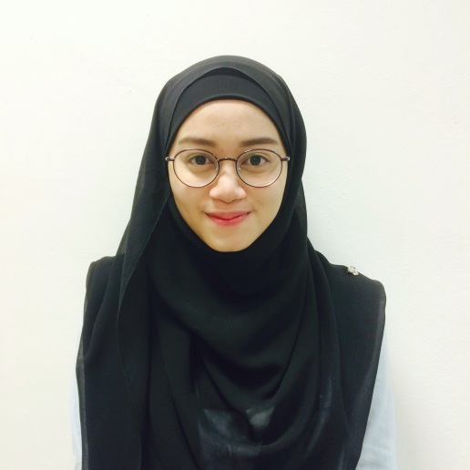

**ZULAIKA NABILA BINTI MOHD OMAR**

**Objective :** To obtain a position as “Customer Service Representative”.

**Address** : 84, Jalan Gigih 1, Taman Sri Lambak, 86000 Kluang, Johor

**Tel (Mobile)** : 019 790 8153 / 018-2378153

**Email** : zulaikanabilamohdomar@gmail.com

**Personal Particulars**

**Age** : 22 Years Old

**Date of Birth** : 11 March 1993

**Gender** : Female

**Nationality** : Malaysian

**Marital Status** : Single

**Educational Background**

***Highest Education***

**Level** : Bachelor Degree (Hons.) (2014 – current) **CGPA:** 3.36

**Field Of Study** : Customer Service Management (BM234)

***Second Highest Education***

**Level**  : Diploma (2011 - 2013) **CGPA:** 3.45

**Field of Study** : Office Management & Technology (OM114)

***Third Highest Education***

**Level**  : Sijil Pelajaran Malaysia (SPM)

**Working Experiences**

**Company Name**  : Pakar Book Center Sdn.Bhd., Kluang, Johor (Sales Assistant)

**Date of Employment** : January 2011 – April 2011

**Company Name**  : Tutti Frutti Seksyen 7, Shah Alam, Selangor

**Date of Employment** : December 2013 – February 2014

**Skills**

* Microsoft Office (Word, Excel, Power Point and Publisher)
* Keyboarding Skills

**Knowledge**

* Basic Knowledge of Office Management
* Basic Knowledge of Customer Service
* Basic Knowledge of ICT
* Basic Knowledge of Entrepreneurship

**Languages**

English Good in writing and speaking

Bahasa Malaysia Excellent in writing and speaking

Mandarin Basic

**Accomplishments and Awards**

**UiTM**

***A. Bachelor Degree***

Participated as Volunteer in Team Building Programme

Participated in Seminar “Looking Good, Feeling Great”

Dean Award Honorees for Semester 4

***B. Diploma***

Contributed in Annual General Meeting for Tun Putih College and Tun Perak College

Contributed as Project Manager in “Week for Love, Fun and Unite 5”

Contributed as Assistant Project Manager in “Program JPAM for Semester 3”

Contributed as Assistant Project Manager in “Let’s Sweep and Sweat”

Contributed in “Car Boot Sale Tun Putih”

Contributed in “Week for Love, Fun and Unite 4 and 6”

Contributed in “Program Iftar Ramadhan”

Contributed in “Program Menggenggam Erat Mengorak Langkah”

Actively participated in Jabatan Pertahanan Awam for Semester 1 – 3

Actively participated in “Citrawarna”

Actively participated in “Sukan Bakat Baru”

Actively participated in “Sukan Antara Fakulti”

Actively participated in “Nature Day Care Programme”

Front Co-ordinator of Event Flow for “Program Iftar Ramadhan”

Dean Award Honorees for Semester 4

**References**

**Name** : Miss Noor Haty binti Nor Azam

Lecturer of Office Management and Technology

Faculty of Business and Management

Universiti Teknologi MARA

UiTM Lendu, Alor Gajah, Melaka

**Tel. No.** : +6013 699 7001

**Name** : Mohammad Zaim bin Mohd Salleh

Lecturer of Customer Service Management

Faculty of Business and Management

Universiti Teknologi MARA

UiTM Puncak Alam, Selangor

**Tel. No.** : +6012 902 4198